SOCI 269

Coding Assignment

Sakeef M. Karim

*Amherst College*

## Basic Expectations

As noted in your [syllabus](https://soci269.netlify.app/), you are required to submit a short coding assignment by Monday, March 10th at 8:00 PM. For this assignment, you will clean a dataset in , report basic descriptive statistics, and create simple data visualizations. You must also include your script file (i.e., a .R document) as part of your submission. Once you’re done, please [submit your materials via Moodle.](https://moodle.amherst.edu/mod/assign/view.php?id=934102)

|  |
| --- |
| You Must Submit Two Separate Files |
| Please remember to submit (i) the code you used to complete the assignment **along with** (ii) a text-based summary of your results. |

## The Data

### Description

You will be working with a truncated version of the 2010 *General Social Survey* (henceforth, GSS). The dataset was prepared using the [{gssr}](https://kjhealy.github.io/gssr/) package in .

You can access the data through one of three channels:

1. By copying and pasting the script below directly into RStudio:

readRDS(url("https://github.com/sakeefkarim/intro_quantitative_sociology/raw/refs/heads/main/data/assignments/coding%20assignment/gss_2010_truncated.rds"))

1. By [downloading](./data/gss_2010_truncated.rds)  the .rds file.
2. By cloning our companion [GitHub repository](https://github.com/sakeefkarim/intro_quantitative_sociology/tree/main).

### Variables

Learn more about the variables in your data by using the interactive table [embedded online](https://soci269-a1.netlify.app/#variables). This table includes data on all variables with labels in the broader (i.e., non-coarsened) 2010 GSS.

## Your Tasks

1. Report the mean for all numeric variables in the data—*with* and *without* weights.[1]

|  |
| --- |
| **Hint**  You may want to explore the [weighted.mean()](https://www.rdocumentation.org/packages/stats/versions/3.6.2/topics/weighted.mean) function. |

1. Report the median age of all respondents *by* race and sex. Concretely, your estimates should provide the median age of Black women, “Other” men *etc.* These results do **not** have to be weighted. That said, if you *want* to generate weighted medians, feel free to explore the [Hmisc::wtd.quantile()](https://rdrr.io/cran/Hmisc/man/wtd.stats.html) function.
2. Report the share of respondents who are Democrats—including Independents who *lean* Democrat and those who do not consider themselves “strong” Democrats. Once again, these results do **not** have to be weighted.[2]
3. Explore the hrsrelax, mntlhlth and physhlth variables. What do they refer to? Are they meaningfully patterned by age, race, religion, sex, sexuality and their many intersections? Using ggplot2, generate **two** simple visualizations that provide preliminary insights based on your exploratory assessments and hunches.

|  |
| --- |
| **Hint**  You may want to use [facet_wrap()](https://ggplot2.tidyverse.org/reference/facet_wrap.html) or [facet_grid()](https://ggplot2.tidyverse.org/reference/facet_grid.html) to simplify your story. |

1. What does the letin1a variable capture? Generate a *third* visualization using ggplot2 that illustrates how letin1a may be socially patterned.

## Formatting Guidelines

You are free to prepare the exposition for your assignment in Microsoft Word, Google Docs, LaTeX, RMarkdown or Quarto. Concretely, this means you can submit your text-based summary as a .docx file or as a . Please use complete sentences to proffer your basic arguments and interpret the results you present. To facilitate interpretation, generate simple tables or plots to summarize descriptive results (i.e., Questions 1-3.)

If you decide to include references, please use [APA](https://owl.purdue.edu/owl/research_and_citation/apa_style/apa_formatting_and_style_guide/general_format.html) *or* [ASA](https://owl.purdue.edu/owl/research_and_citation/asa_style/index.html) citation styles to manage references and bibliographies.[3] More generally, *you must use subheadings to organize your arguments*.

## 

## Bonus

|  |
| --- |
| These Are Bonus Questions |
| You do **not** have to submit answers to these questions. They are *bonus* items for students with prior exposure to ggplot2 (or those who want more practice). |

1. Reproduce the plot below using gapminder and the ggthemes package.

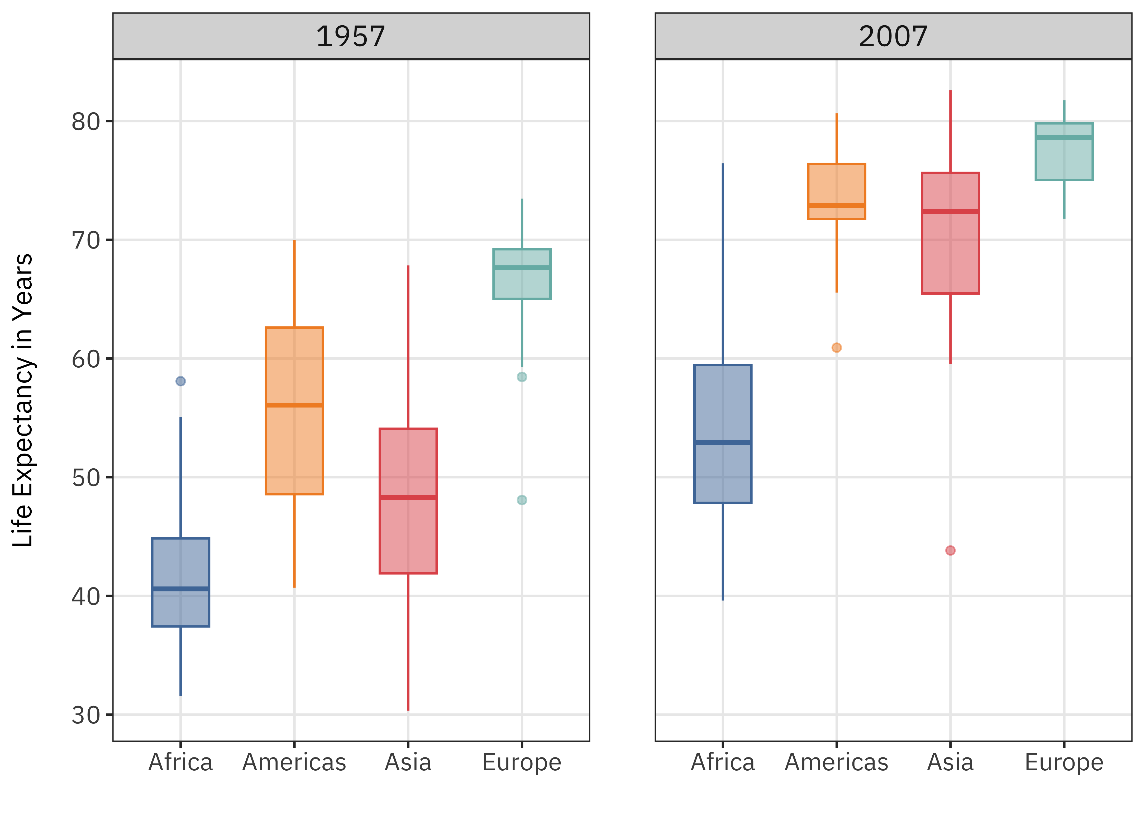

1. Reproduce the plot below using the see package and geoms from ggdist.

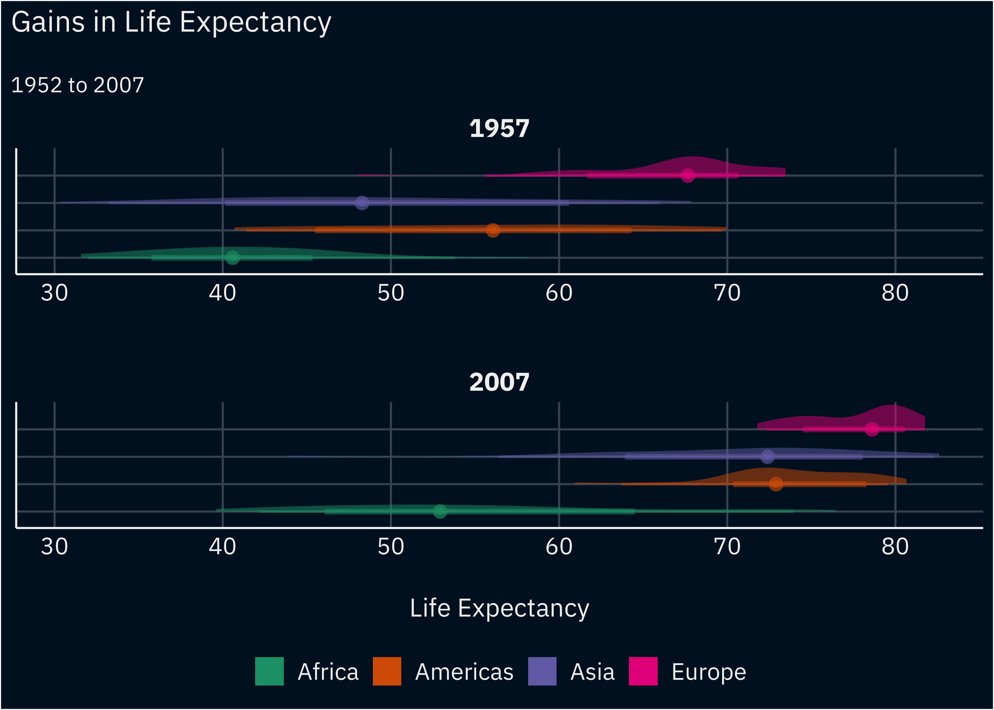

1. Produce a map of Greater Boston that speaks to the racial diversity of the city.
2. Use dplyr functions to merge the coarsened 2010 GSS (gss_2010_truncated.rds) with interesting variables from the broader 2010 GSS file (gss_2010.rds).

1. You do not need to provide means for the weighting variable.
2. You are, however, free to produce weighted estimates.
3. If you haven’t done so already, you may want to invest in [Zotero](https://www.zotero.org/) to manage your citations.